**CURRICULAM VITAE**

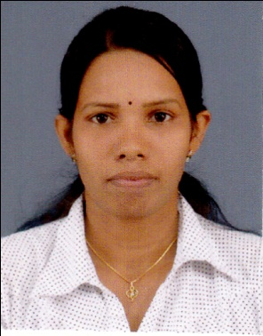

**VANAJA PONNAMPALAM**

**Bachelor of Science Degree in Computation & Management**

Kulavisuddan, Nedunkerny, Vavuniya.

TP: 0775171554

Suganja2010@gmail.com

**Academic & Professional Activities**

* Bachelor of Science Degree in Computation & Management Expected in 2015, **University of Peradeniya (English medium).**

|  |  |  |
| --- | --- | --- |
| **Management** | **Economics** | **Computer science** |
|  |  |  |
| * Marketing Research management | * Micro economics | * Software engineering |
| * Business Accounting * Strategy management | * Macro economics | * Computer networks |
| * Operation management |  | * Distributed system |
| * International Human resource management | **Mathematics** | * Data structure |
| * Management information system | * Linear programming | * Object oriented analysis |
| * Cost accounting | * Probability | * Data base management system |
| * Financial accounting | * Graph& Game theory | Programming with C and java |

**Educational Qualification at School level**

* G.C.E Advanced Level Examination Commerce Stream 2009(Index no – 3293955) M**/Vidyananda College.**
  + - * Accounting A Z-score 1.1013
      * Economics B District Rank 03
      * Business Studies C
* G.C.E Ordinary Level Examination 2004, (Index no – 40269728) **K/ Jeyapuram G.T.M. S**
* 3A -Tamil, Commerce , Religion
  + 3B -Mathematics, Social, Health Science)
  + 3C - Tamil literature, Science, English
  + S - Music

**Skills/Qualifications**

* Computer literate in Microsoft Office, Social Medias & Programming languages (C, C++, Java)
* Experience and internship trainee in Bank of Ceylon for three months.
* Team working & leadership skills through experience in academic work projects.
* Experience in QuickBooks Accounting package.
* Can build a Strong Communication. Have good presentation.
* Get on well with people at all levels, easily making good working relationships.
* Proficient in three Languages (English, Tamil, Sinhala (Written & Spoken)).

**Extracurricular Activities**

* Certificate in English course in university of Peradeniya.
* Certificate in Sinhala course in university of Peradeniya.
* Certificate in Spoken English course in British college (Kandy).
* Certificate in sports at district level and school level (Hurdle, put shot, javelin throw. Race, discus throw, netball).
* 1st runner up in volley ball at district level.
* Participating Coaching Camp in netball.
* 1st place in writing poem (Tamil) at district level.

**Personal Information**

* Full Name : Vanaja Ponnampalam.
* Address : Kulavisuddan, Nedunkerny, Vavuniya.
* TP No : 0775171554.
* Email :suganja2010@gmail.com
* Gender : Female.
* Date of Birth : 25/10/1988.
* Nationality : Sri Lankan Tamil.

**Referees**

|  |
| --- |
| Dr. John Nigel (Head), |
| Economics & statistics department, |
| Faculty of arts, |
| University of Peradeniya. |
| Email**:**nigelvccn@yahoo.com |

I hereby certify that the above particulars given by me are true and accurate to the best of my knowledge.

Thanking You.

Yours sincerely, Date:

(P.Vanaja). 16.02.2016